Principles of Date-Base Management System

Prashanth.S(19MID0020)

Table creation and inserting the data

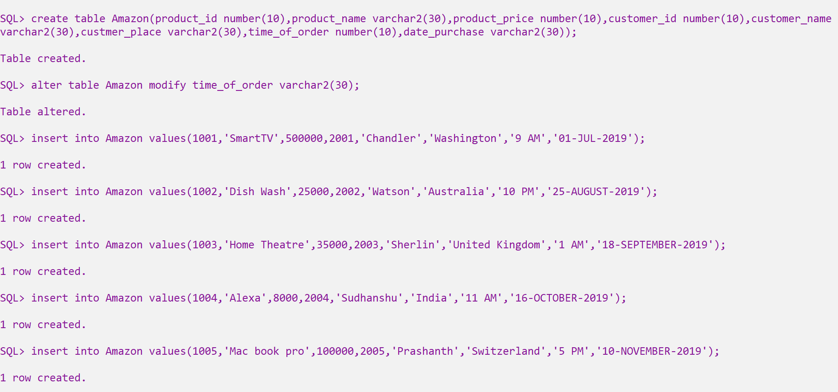

Description of the table

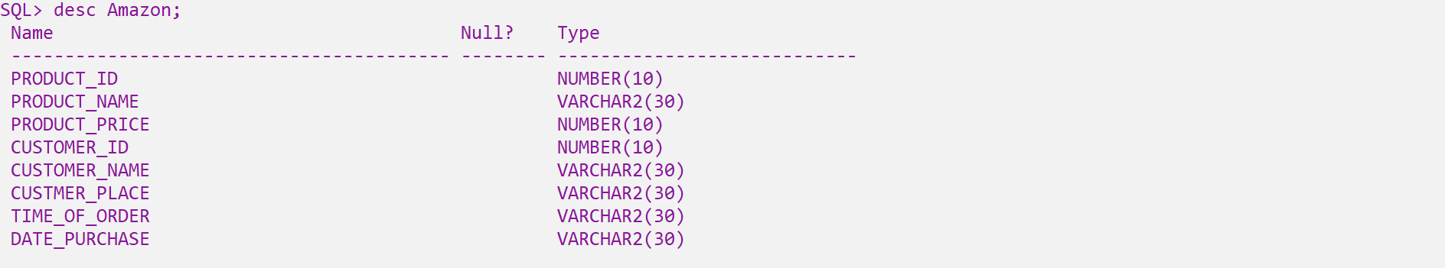

Data’s inside the table

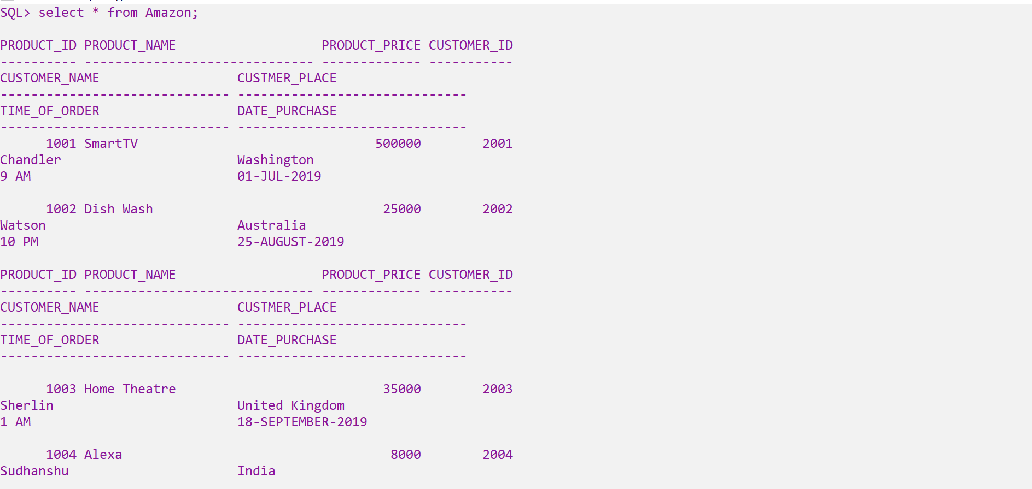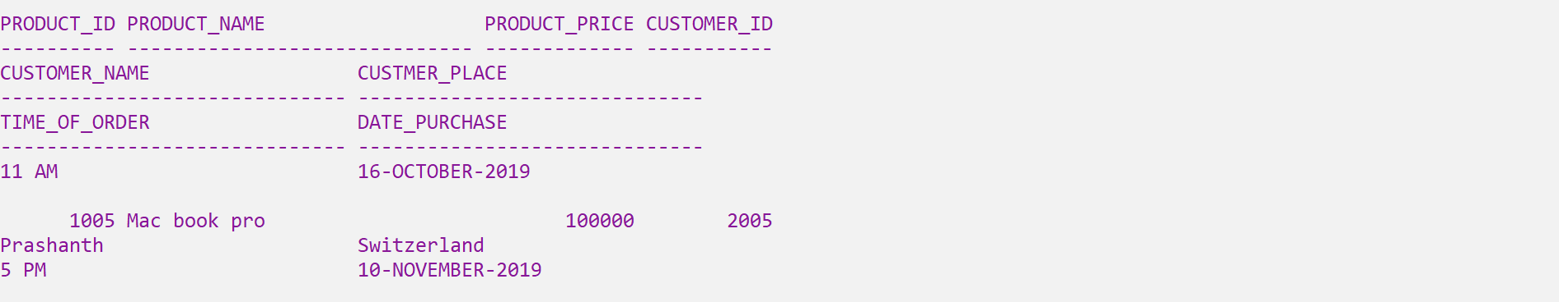

SELECT * FROM <table_name> WHERE <attribute_name>=’data’ AND <attribute_name>=’data’

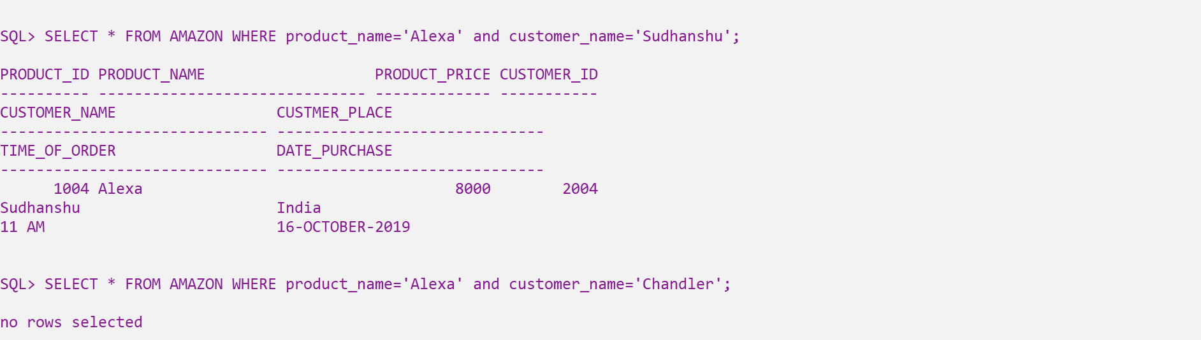

SELECT * FROM <table_name> WHERE <attribute_name>=’data’ OR <attribute_name>=’data’

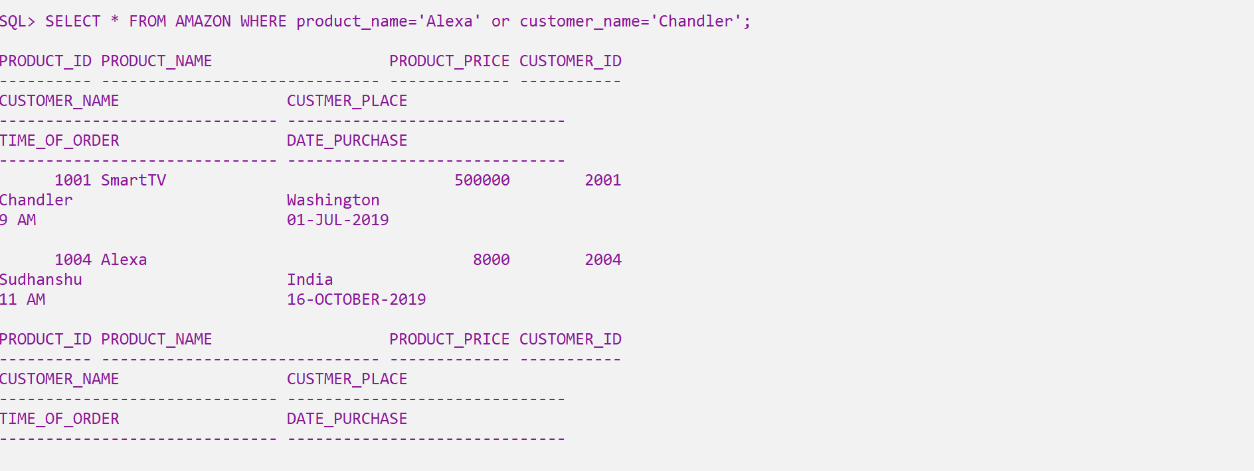

Though both the attributes’s values are not present in the same row, that corresponding data’s entire row is displayed.

SELECT * FROM <table_name> WHERE NOT <attribute_name>=’data’

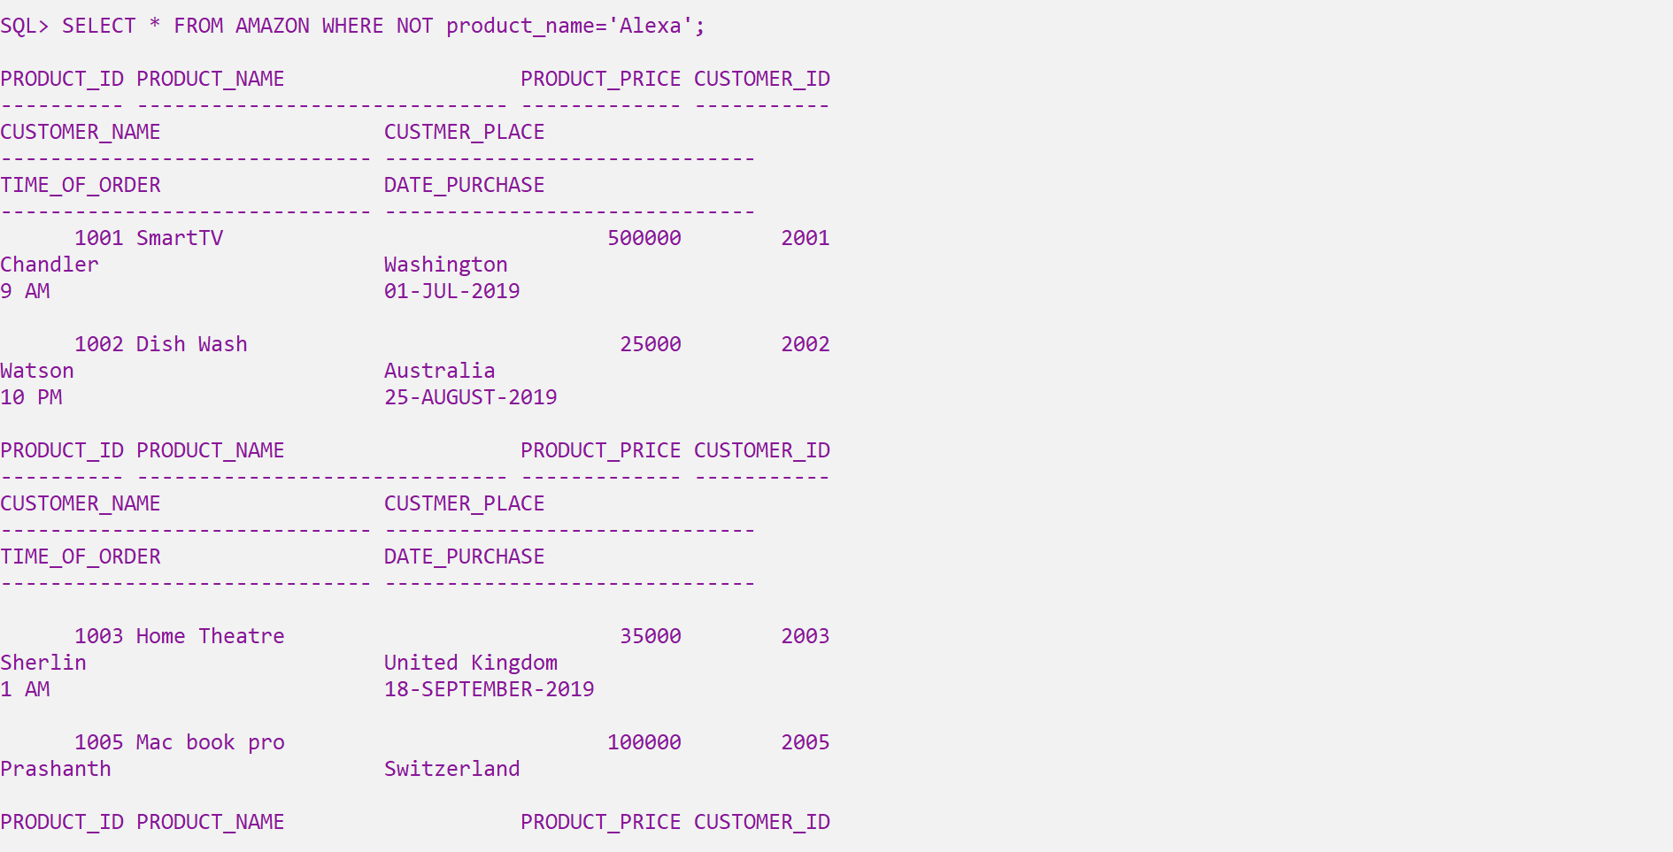  
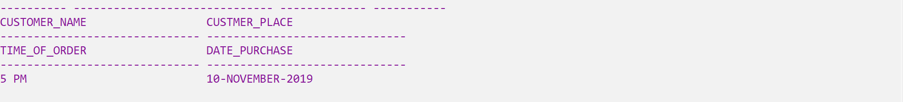

Except ‘Alexa’ data’s row all other rows are displayed

SELECT * FROM <table_name> WHERE NOT <attribute_name>=’data’ AND <attribute_name>=’data’

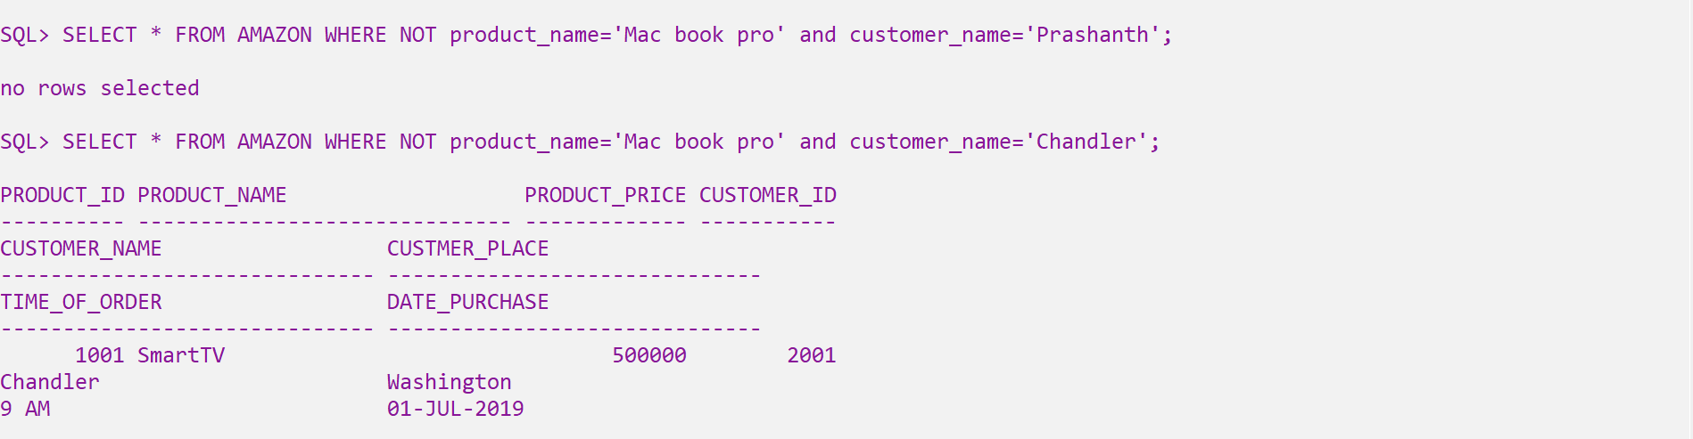

SELECT * FROM <table_name> WHERE NOT <attribute_name>=’data’ OR <attribute_name>=’data’

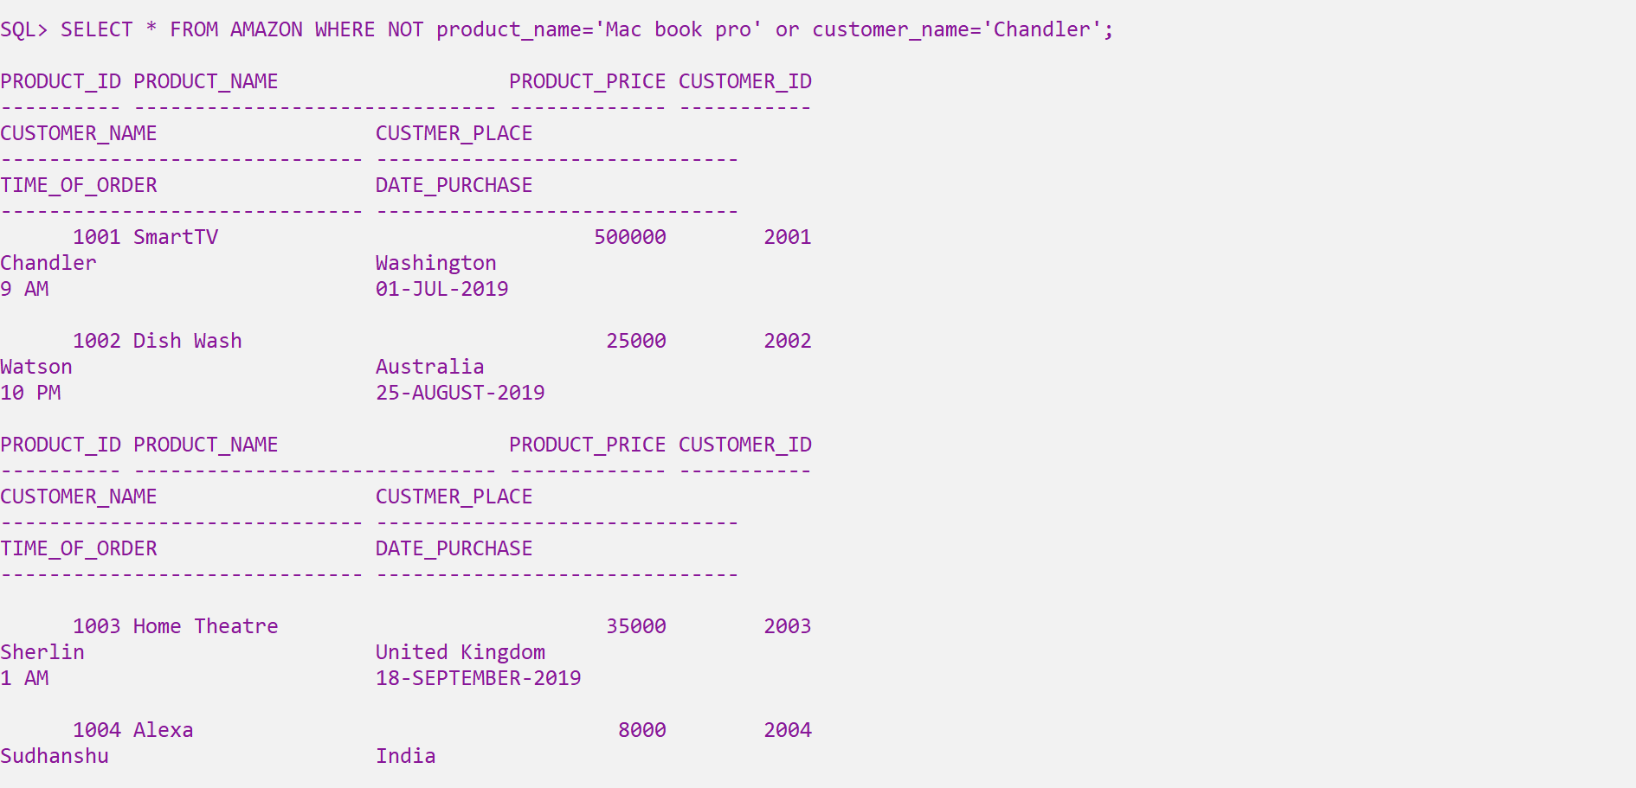  
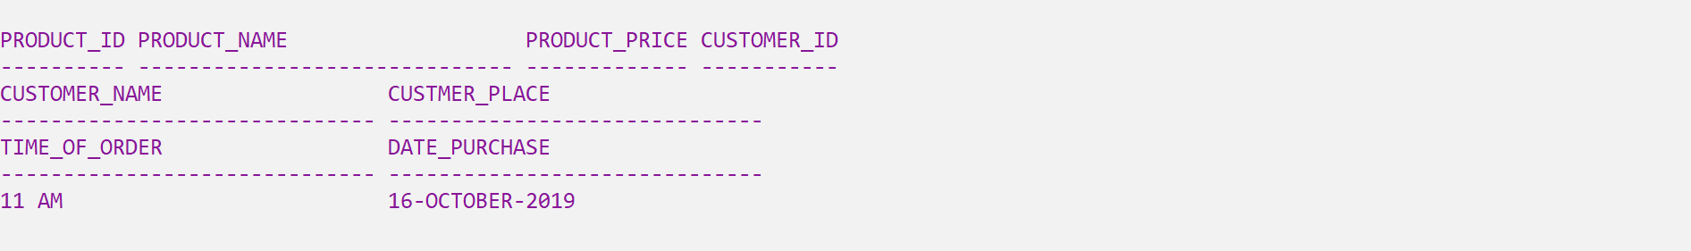

Except ‘Mac book pro’ datas row, all other rows are displayed.

SELECT * FROM <table_name> WHERE <attribute_name>=’data’ AND( <attribute_name>=’data’ OR <attribute_name>=’data’)

SELECT * FROM <table_name> WHERE <attribute_name>=’data’ AND( <attribute_name>=’data’ AND <attribute_name>=’data’)

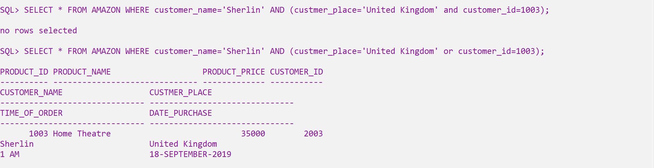



Since Sherlin’s customer id is wrong, no rows are selected.



Even-though there is a wrong customer id, the mistake is ignored.

SELECT * FROM <table_name>   
2 ORDER BY <attribute_name> DESC;

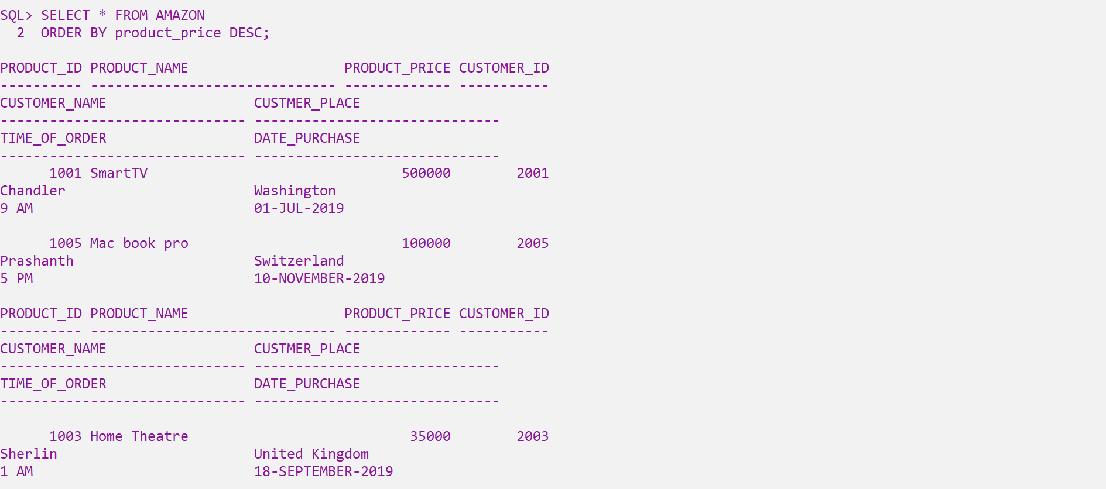  
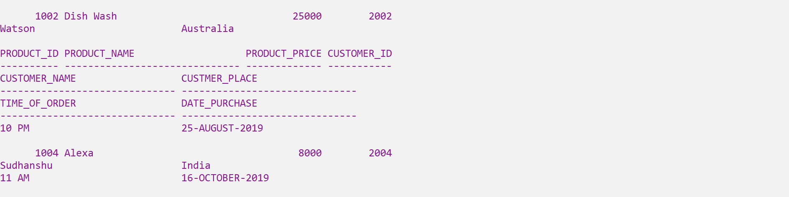



The prices are arranged in descending order

SELECT * FROM <table_name>   
2 ORDER BY <attribute_name> ASC;

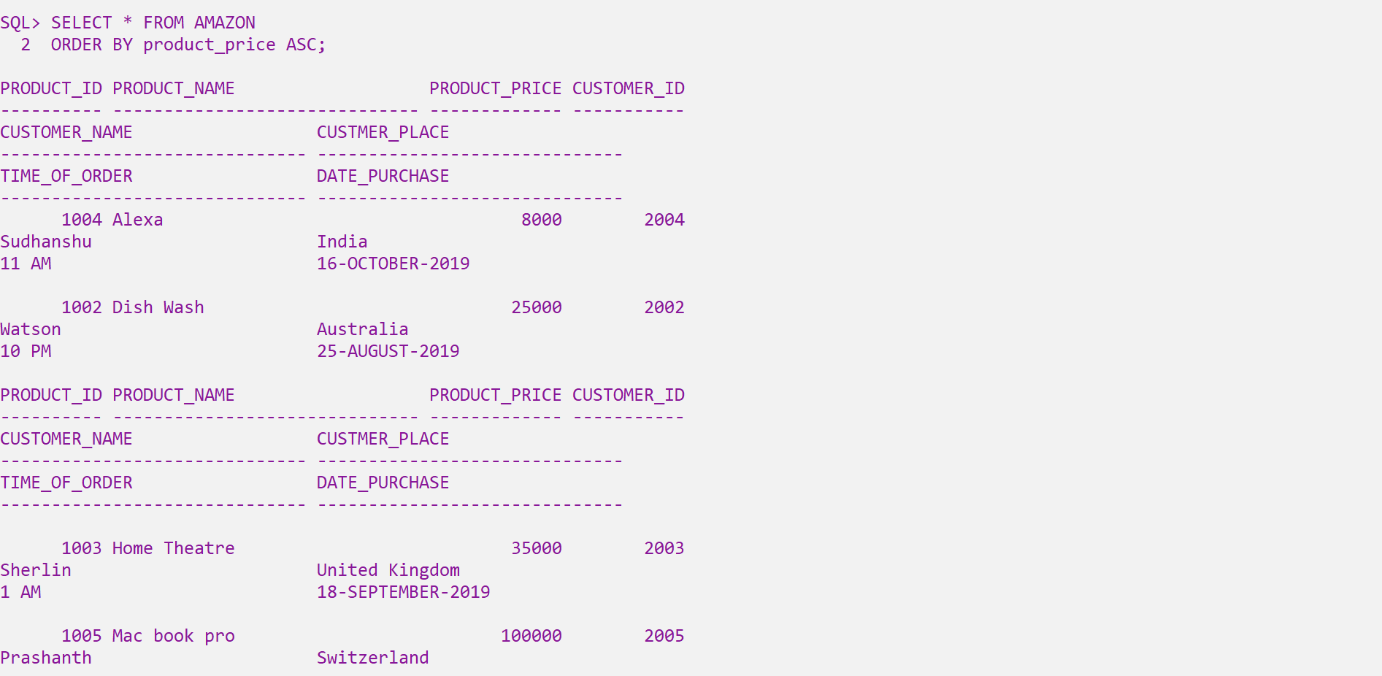  
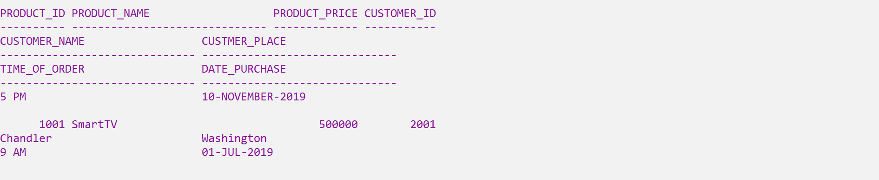



The prices are arranged in ascending order

SELECT * FROM <table_name>   
2 ORDER BY <attribute_name> <attribute_name>;

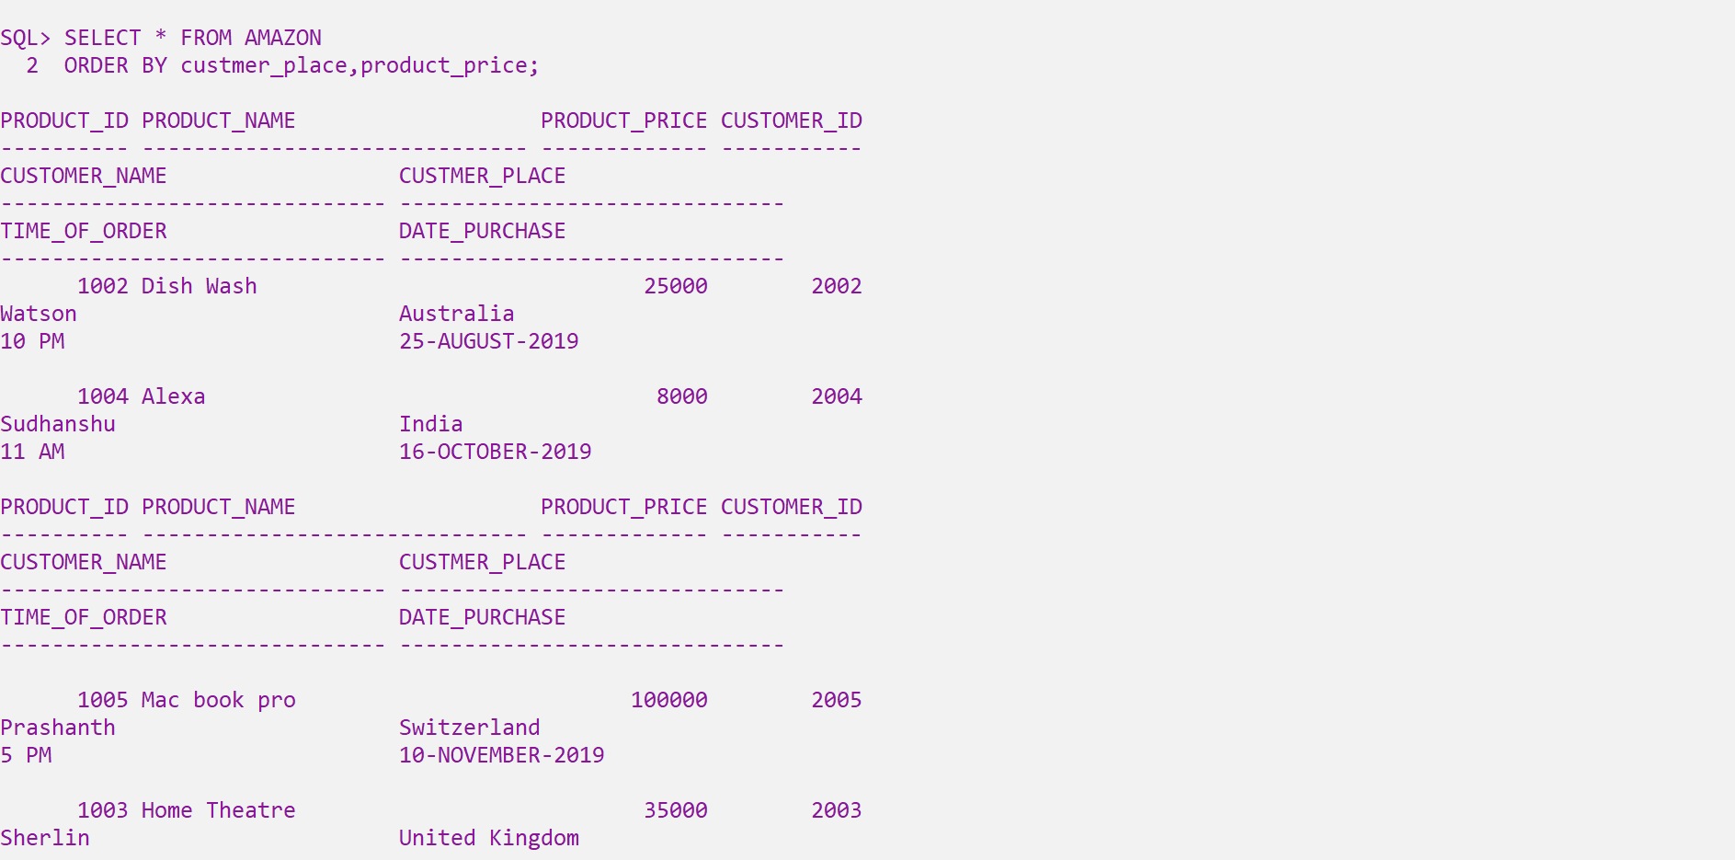  
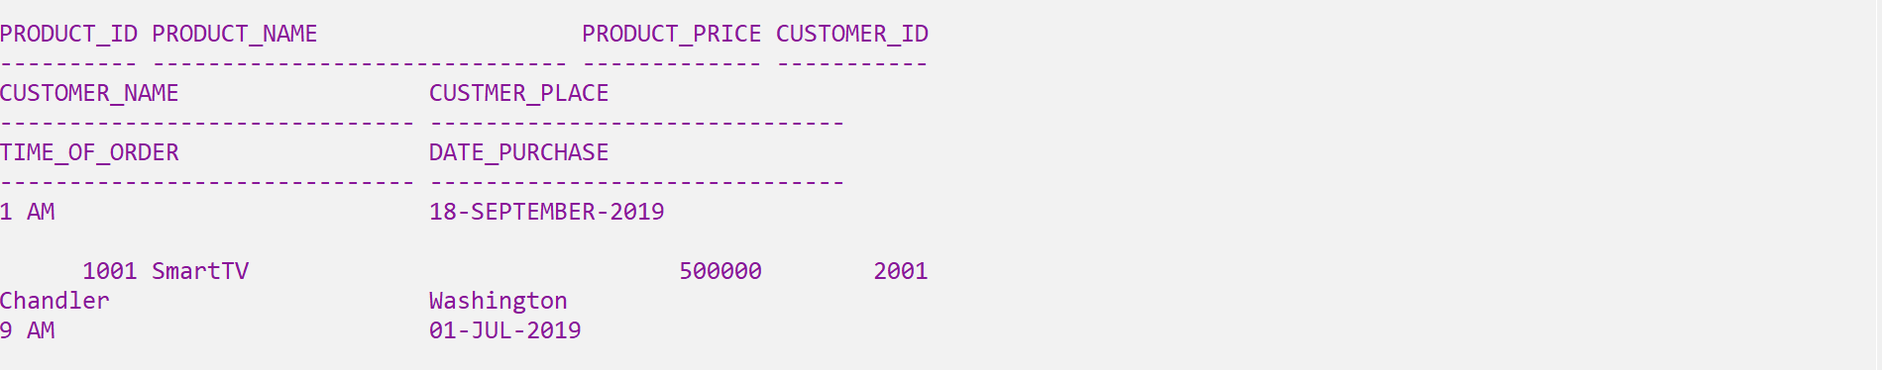

SELECT * FROM <table_name>   
2 ORDER BY <attribute_name> ASC,<attribute_name> DESC;

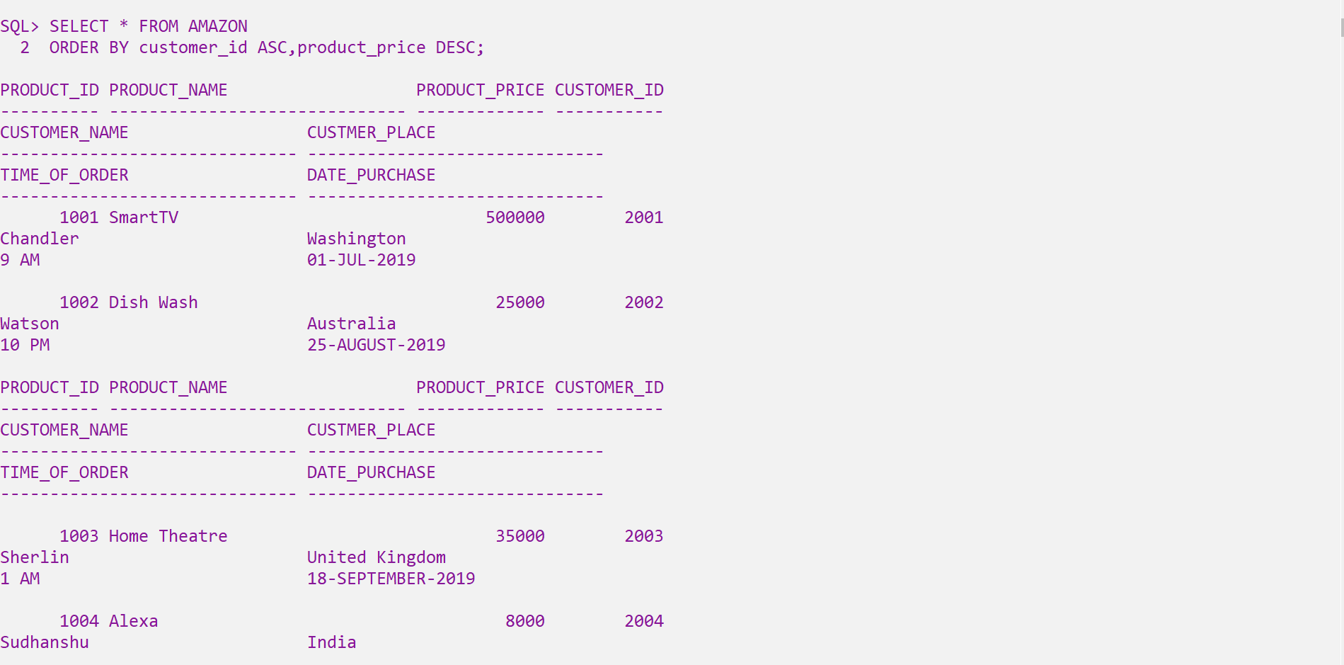  
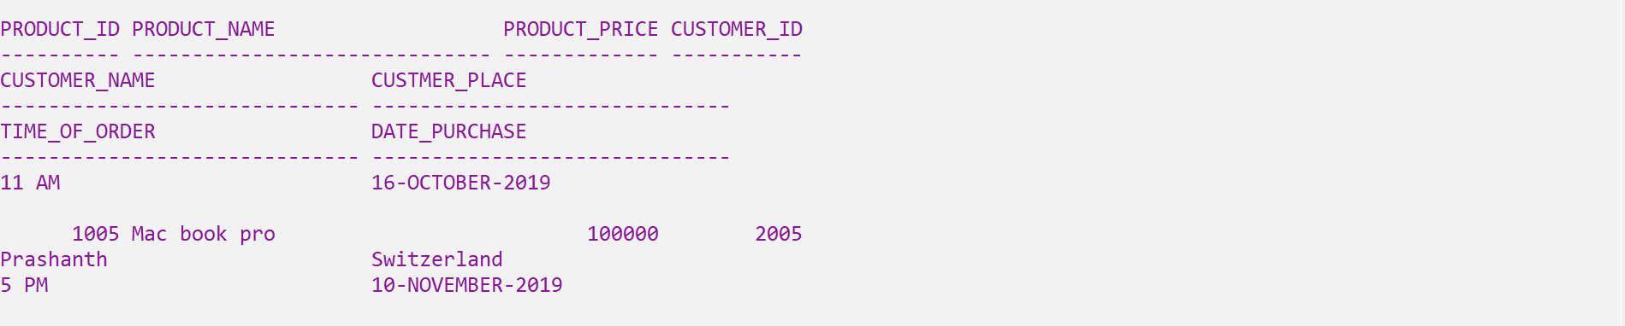

SELECT DISTINCT <attribute_name> FROM <table_name>;

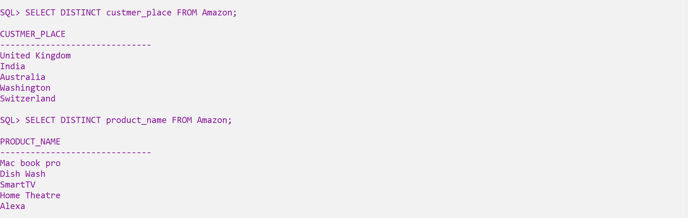

  


SELECT ROUND(<attribute_name>) from <table_name>;  
SELECT UPPER(<attribute_name>) from <table_name>;

SELECT LOWER(<attribute_name>) from <table_name>;

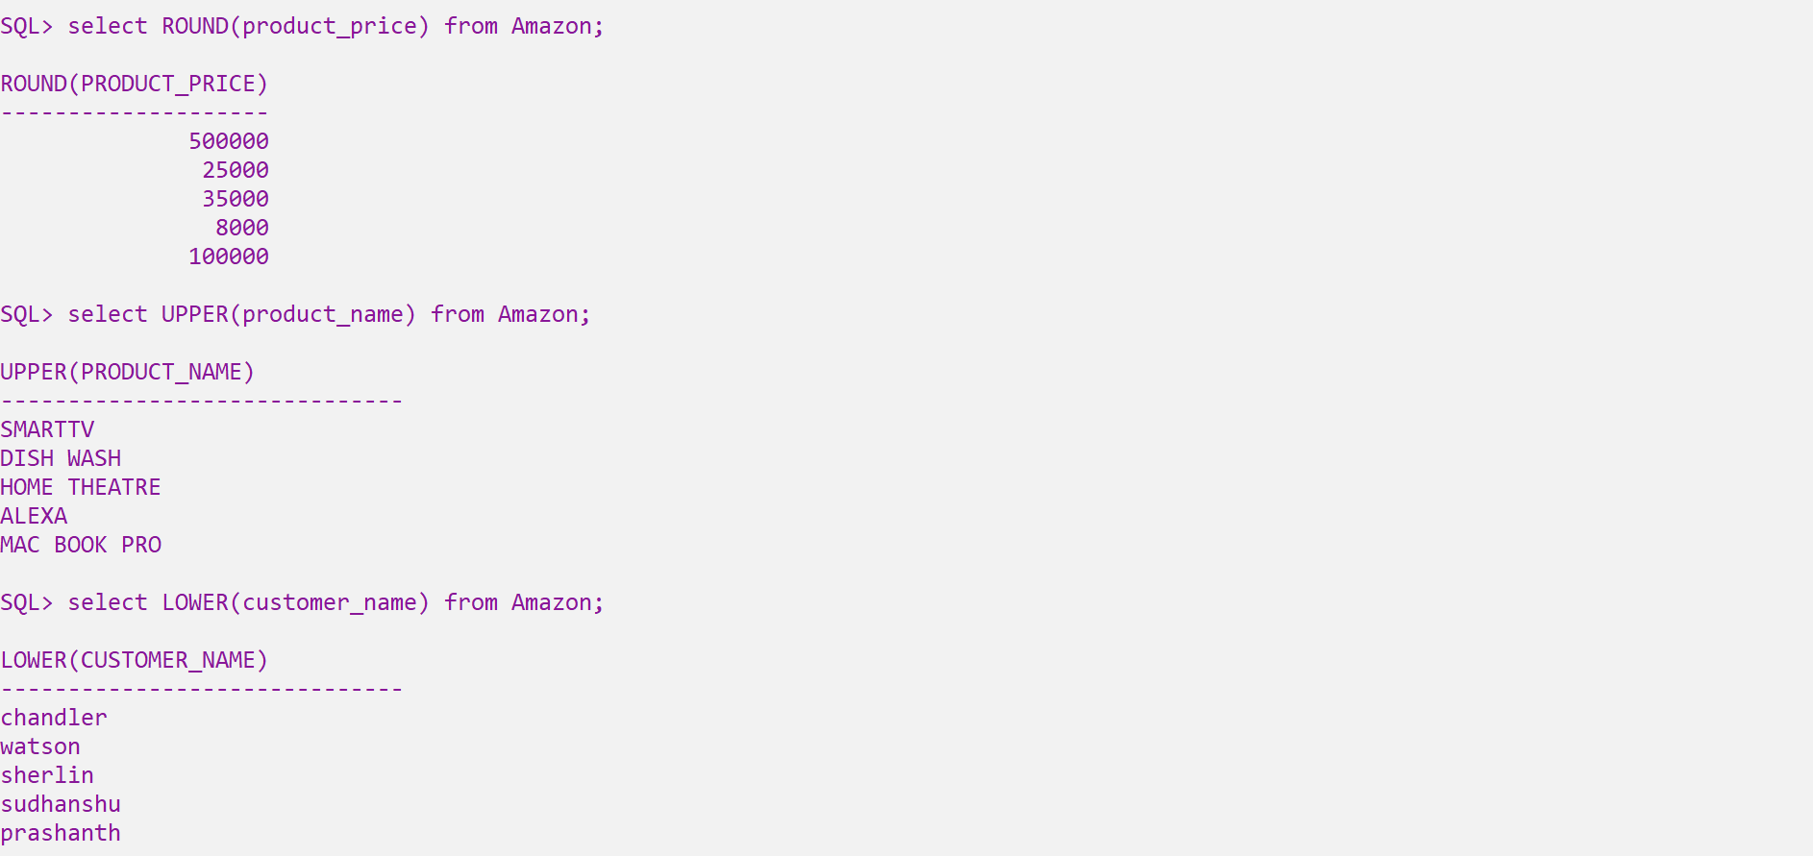

SELECT CONCAT(<attribute_name>,<attribute_name>) from <table_name>;

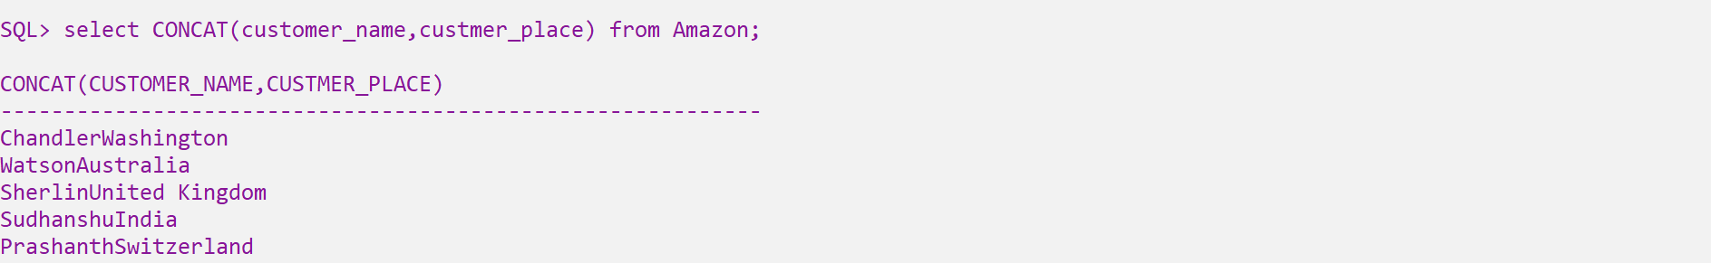

SELECT LENGTH(<attribute_name>) from <table_name>

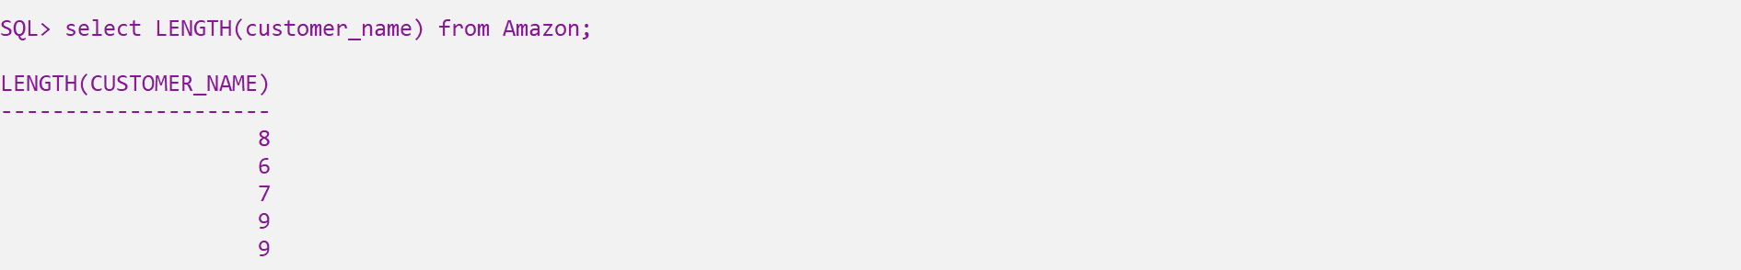

SELECT SUBSTR(<attribute_name>,start,end) from <table_name>  
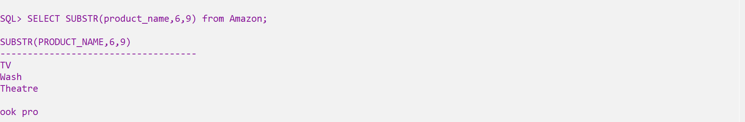

SELECT INSTR(<attribute_name>, ‘ content_name’ ) from <table_name> where constrain

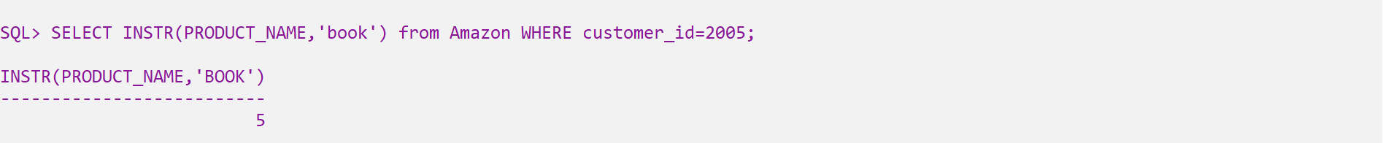

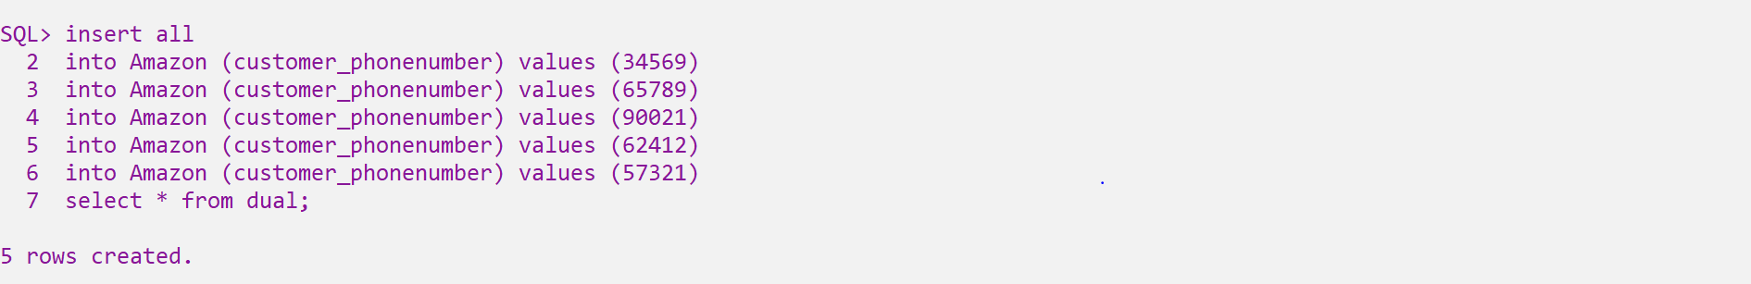

SELECT LPAD(<table_name>,8,'x') from <table_name>;  
SELECT RPAD(<table_name>,8,'x') from <table_name>;

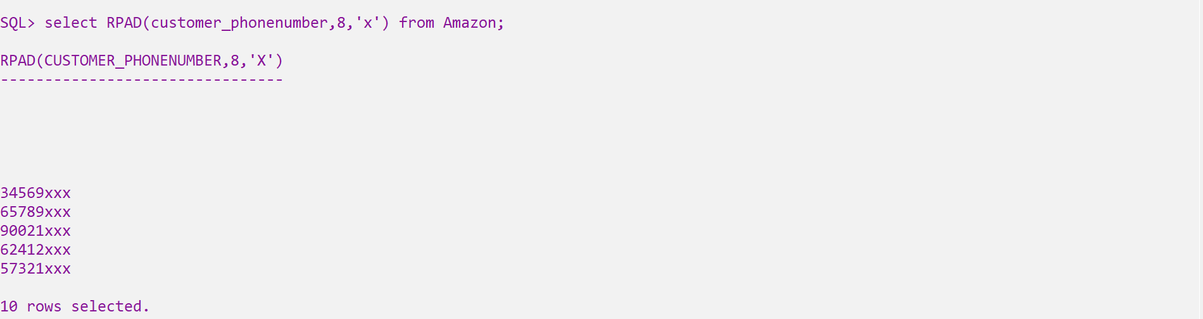  
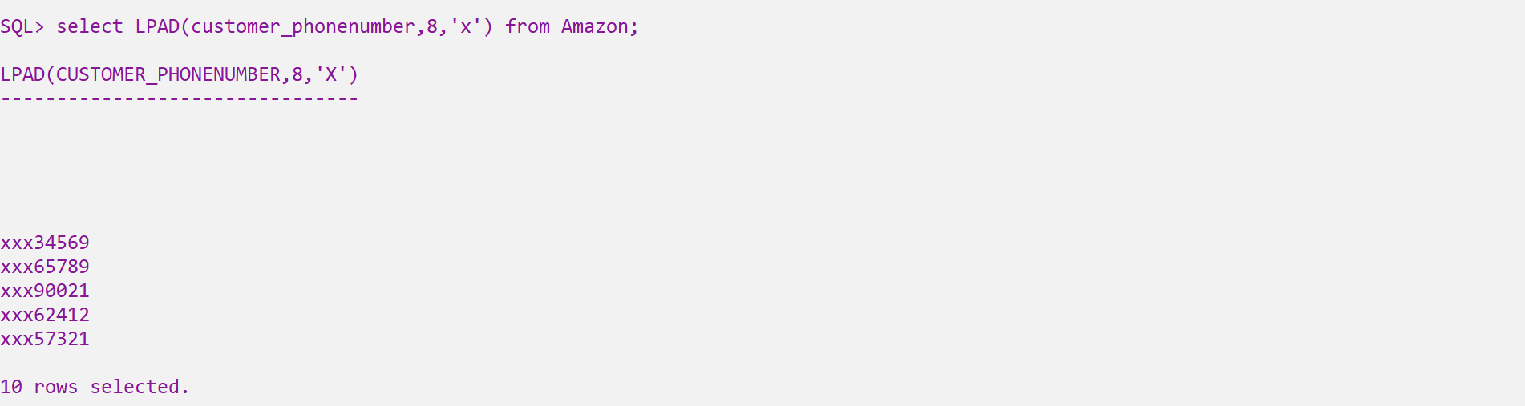

Select TRIM(<letters> from <string>) from <table_name>

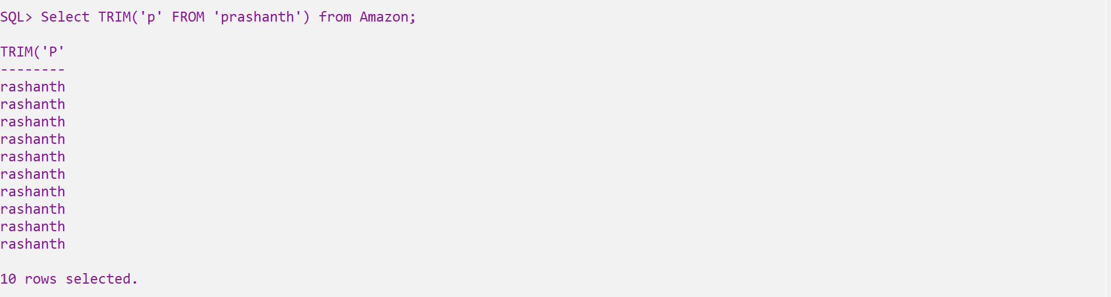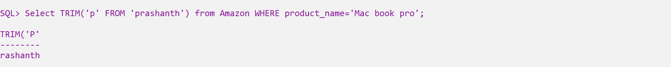

Present purchase_date

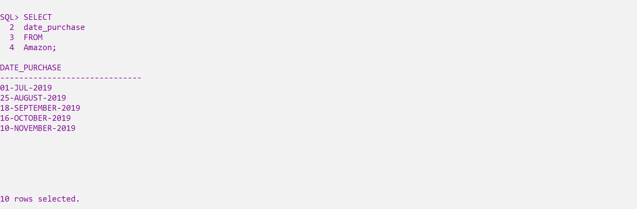

SELECT add_months(<column_name>,3) FROM <table_name>

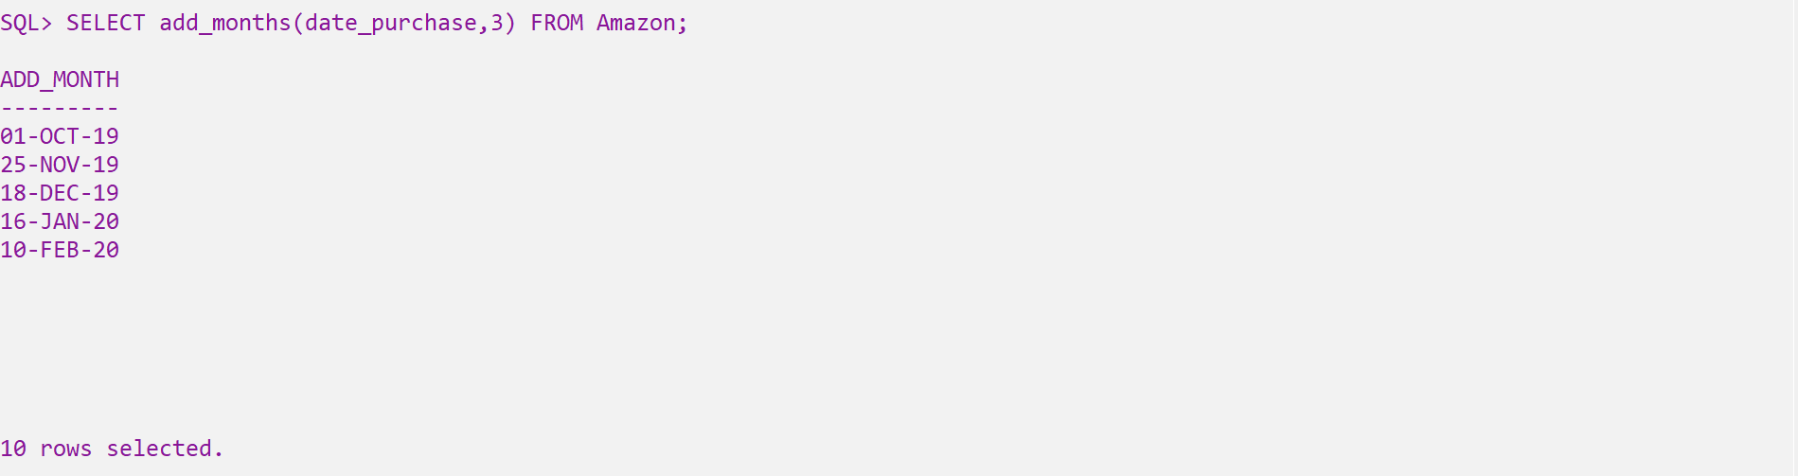

From the present date to date after 3 months

SELECT add_months(<column_name>,-3) FROM <table_name>

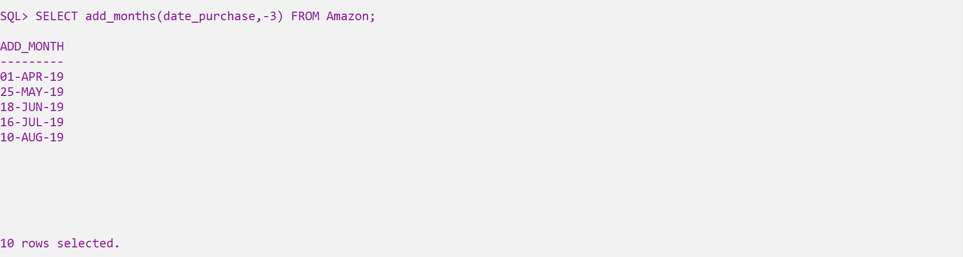

From the present date to date before 3 months

SELECT last_day(<column_name>) FROM <table_name>;

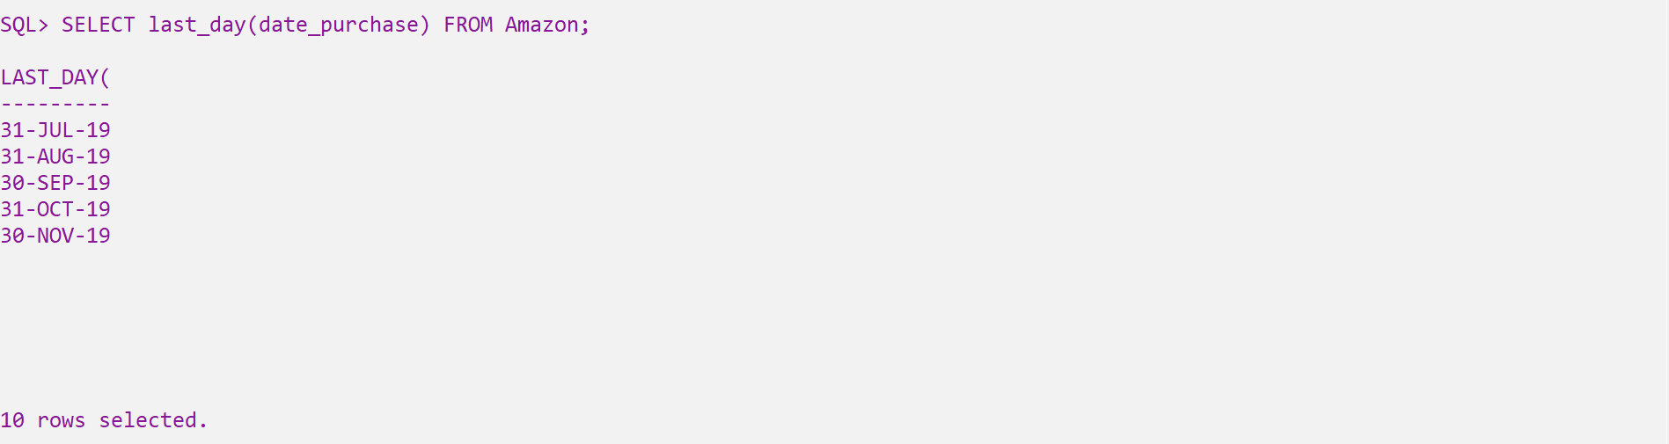

Last day of that particular month

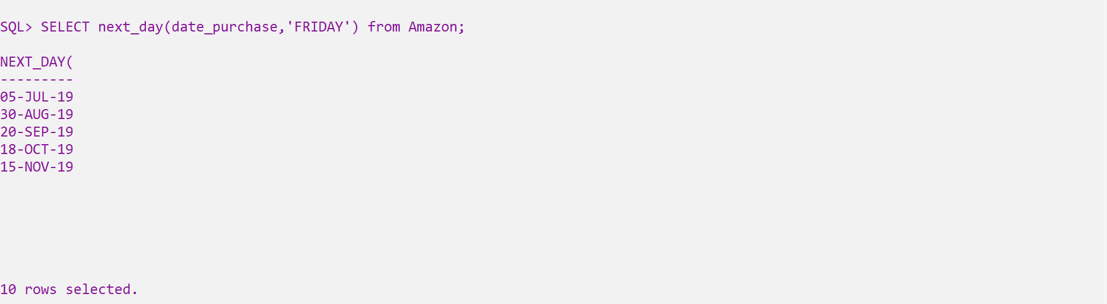

SELECT <column_name>,ceil(<column_name>) from <table_name>

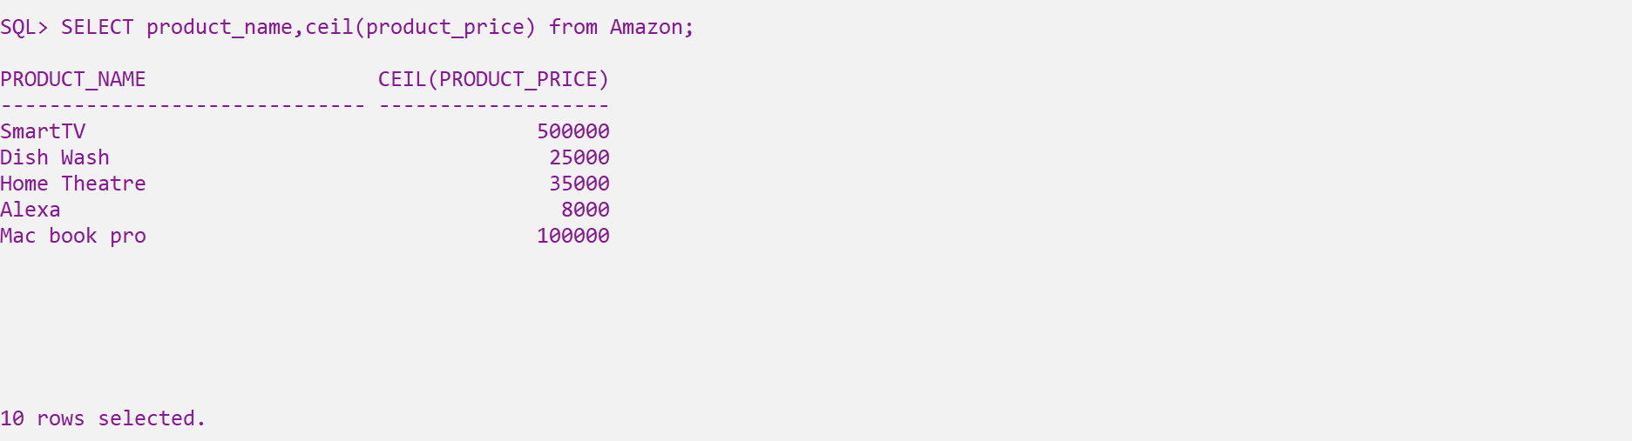

SELECT mod(number1,number2) from dual;  
SELECT power(number1,number2) from dual;

